CREATING A CONSTITUTION

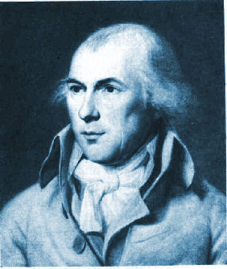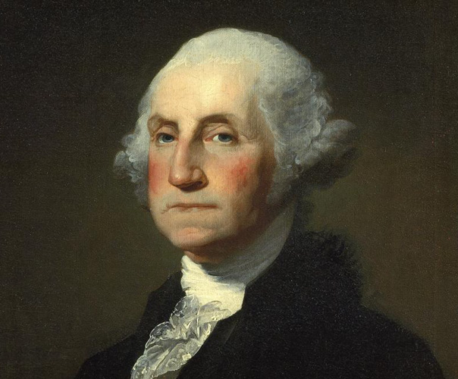

1) How long did Ben Franklin think the Constitution would last?

2) What was our first constitution called?

3) What was the breaking point for the Articles of Confederation?

4) Where was the convention held to discuss fixing the A of C?

5) Who came to the convention with a clear plan for how to move the country forward?

6) Who was the “indispensable” person at the convention?

7) What was the convention supposed to do?

8) Who proposed that the A of C be abolished?

9) The checks and balances among the three branches of government is compared to which
children’s game?

10) What was the compromise called regarding how the president should be chosen?

11) Which states didn’t like the idea of proportional representation?

12) Which delegate created a bicameral compromise that settled the representation issue?

13) What was the phrase “other persons” in the Constitution code for?

14) Which states wanted slaves to count as whole persons? Why?

15) Had the Framers in Philadelphia attempted to abolish slavery in the Constitution, what would
have likely happened?

16) Since the Framers didn’t think the Constitution was perfect, what did they allow in Article V?

17) Where was the Bill of Rights written?

18) What document allows us to live by our founding principles every day?

AFTER VIEWING: Discuss the important role that compromise played during the Philadelphia
Convention. Use specific examples to illustrate.

